Name:
Hundreds feared dead in Haiti earthquake
ABC Report
On January 12th, 2010 the worst earthquake in 200 years - 7.0 in magnitude - struck less than ten miles from the Caribbean city of Port-au-Prince, Haiti. The initial quake was later followed by twelve aftershocks greater than magnitude 5.0. Structures of all kinds were damaged or collapsed, from shantytown homes to national landmarks.
Major buildings including offices, hotels and shops collapsed when a massive earthquake hit Haiti's capital, burying hundreds, possibly thousands of people beneath rubble, an aid worker with a US charity said.
"The whole city is in darkness, you have thousands of people sitting in the streets, with nowhere to go," Rachmani Domersant, an operations manager with Food for the Poor, told Reuters from Port-au-Prince.
"I've seen seven to eight buildings, from office buildings to hotels and shopping stores, collapsed or burning ... I think hundreds of casualties would be a serious understatement," he added.
Haiti's ambassador to the US says the earthquake has caused a "catastrophe of major proportions" and there are reports of mass panic, with screaming people rushing into the streets as buildings collapsed, throwing a pall of dust over the city.
This morning a local doctor told AFP that he feared the death toll would be significant.
"When we get an idea of the toll it will be measured in the hundreds," the doctor said.
The epicenter of the quake was located inland, just 16 kilometers from the capital, and was a shallow 10km deep, intensifying its impact, and significant casualties are expected.
Reuters reporter Joseph Guyler Delva says he saw dozens of people apparently dead or injured lying under rubble, which blocked roads.
"Everything started shaking, people were screaming, houses started collapsing... it's total chaos," he said
The national director of World Vision in Haiti, Frank Williams, is just outside Port-Au-Prince.
"People are screaming all around and walls from buildings and private residences have fallen into the streets, so that has pretty much blocked off most of the traffic," he said.
"We have some aftershocks that we've experienced... people are wailing... [are] very frightened. Most of the people are out on the streets."
The earthquake hit at 4.53pm (local time) in an extremely populated area. A US Geological Survey official told CNN that significant casualties were expected.
Haiti's ambassador to the US Raymond Alcide Joseph told CNN he was heartbroken as he had just spoken by telephone with a senior presidential aide who described scenes of chaos and devastation.
"He had to stop his car just about half an hour ago, and take to the streets, start walking, but he said houses were crumbling on the right side of the street and the left side of the street," Mr Joseph said.
"He does not know whether he would reach his home, not knowing what he would find, because he had a bridge to cross to get there."
The presidential palace in Port-Au-Prince collapsed and many other public buildings across the capital were destroyed, Haitian television streaming online reported Tuesday.
"The presidential palace, the finance ministry, the ministry of public works, the ministry of communication and culture," were all affected by the quake, a Haitian reporter said, adding that the parliament building and a cathedral in the capital were also crumbling.
Earthquakes are the shaking, rolling or sudden shock of the earth’s surface. They are the Earth's natural means of releasing stress. More than a million earthquakes rattle the world each year.
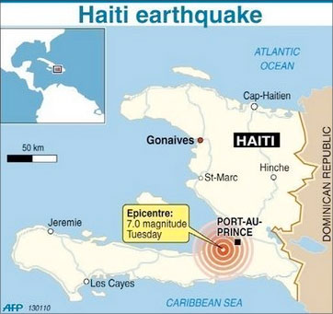
Location of Haiti and Epicentre

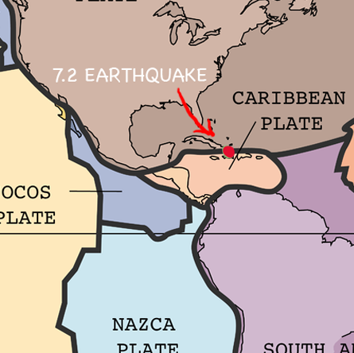
Map showing plate boundaries

An earthquake is what happens when two tectonic plates of the Earths crust suddenly slip past one another. The surface where they slip is called the fault or fault plane. The location below the earth’s surface where the earthquake starts is called the focus , the location directly above it on the surface of the earth is called the epicenter.
Key word | Definition
Epicenter
Fault line
Focus

- What was the strength of the earthquake? What units is it measured in?

- Why do you think the whole city was in darkness?

- Why could an earthquake start fires?

- Rachmani Domersant said he thought there would be hundreds of casualties. What was it that would have killed and injured people

- Frank Williams mentioned aftershocks. What are aftershocks?

- Mr Joseph said that a presidential aide had to stop his car and walk. Why did he need to do that?

- Give at least 2 reasons why you think it would be difficult for the government to control a rescue and response plan to the disaster?

- Since the earthquake there has been an outbreak of the disease Cholera. Can you think of why.

- Look at the maps showing the location of the quake and the location of the plate boundaries. Does this information give you a clue as to why there was an earthquake in Haiti?

